Outstanding-1

1. Create a Resource group by Name (rg01)

Go to Resource group > + add

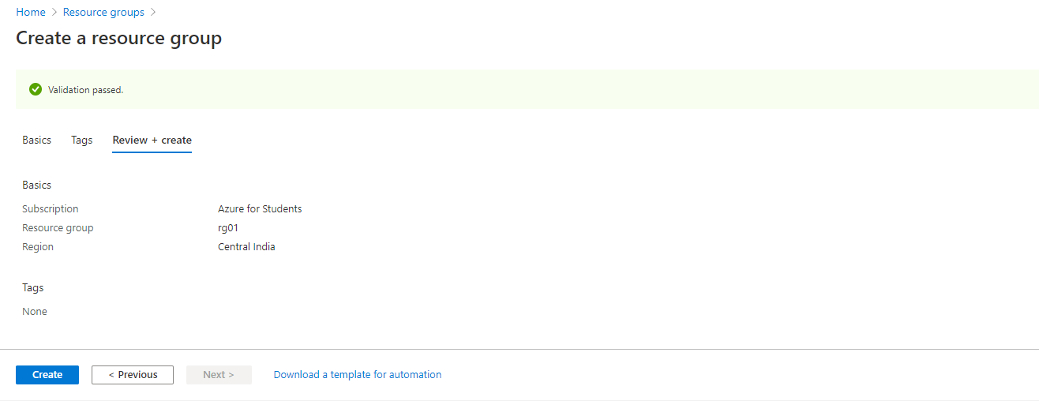

2. Create two virtual network’s using different address space.

a. Vnet-01

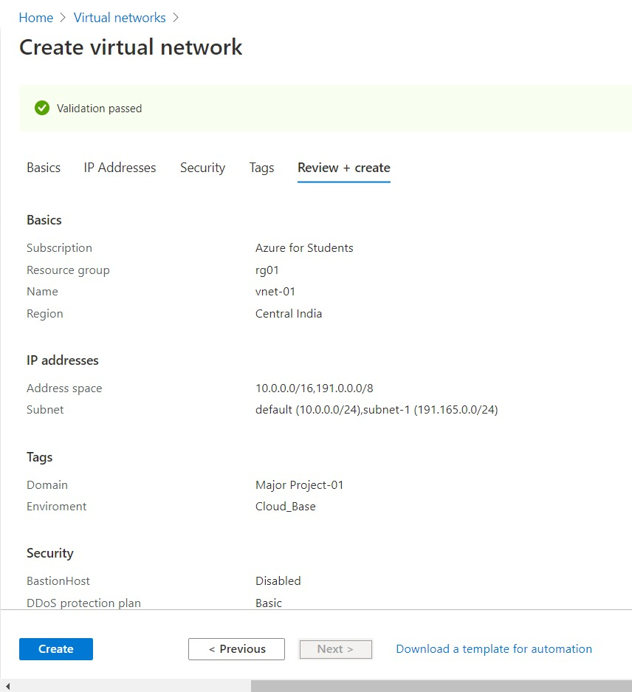

b. Vnet-02

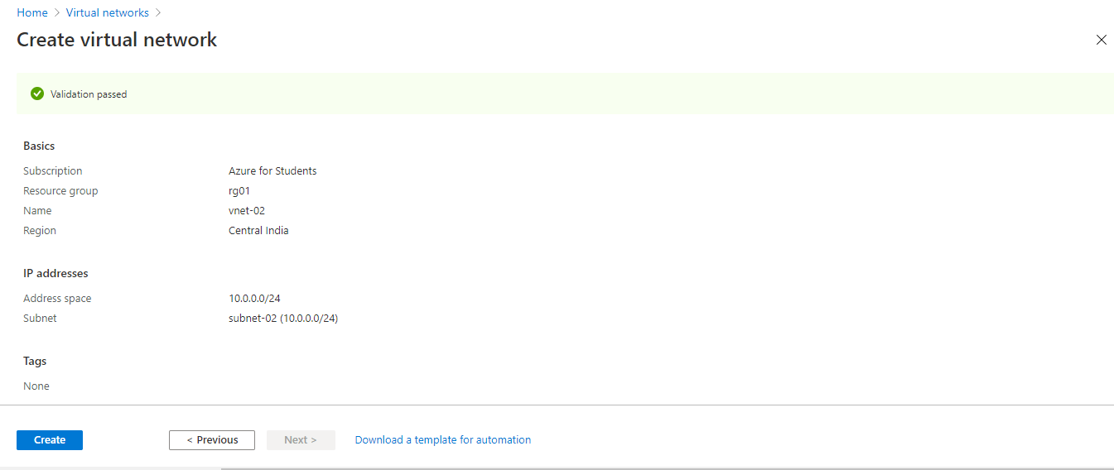

3. Create two VM’s (one Linux and one Windows) in each created Virtual Networks above respectively.

a. Linux VM

Go to Virtual machine > + add and configure it. Here we creating linux VM which uses ssh protocols.

While configuring it you will see a **Administrator account (** user credentials) add putty client to generate the public-private key.

In SSh public key update the public key and set other configurations by default.

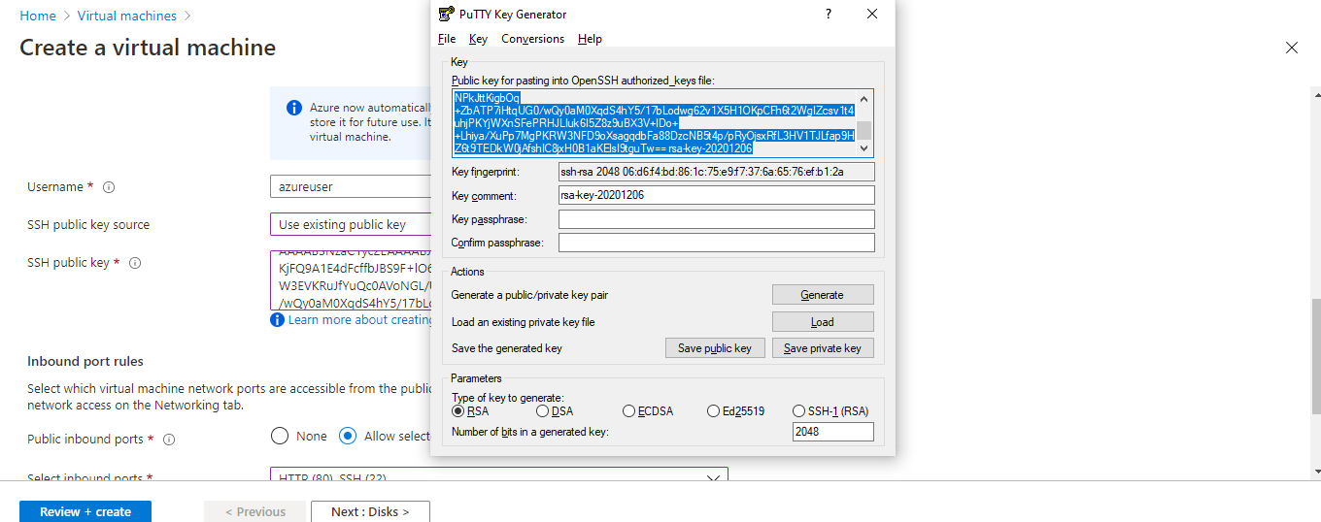

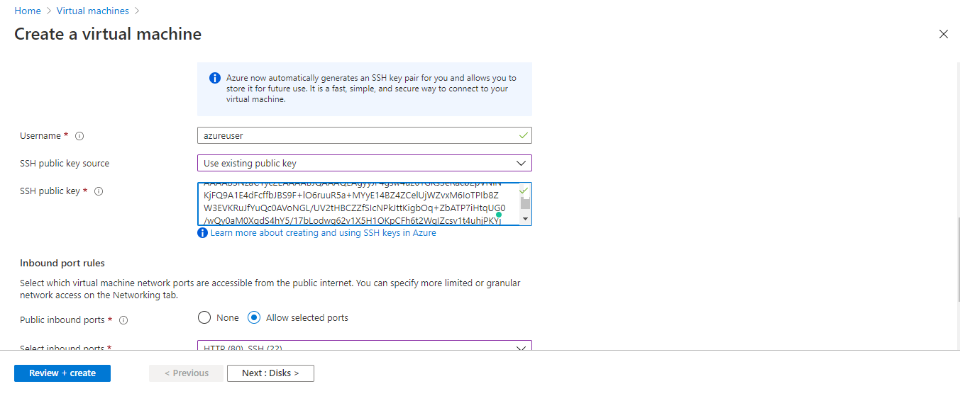

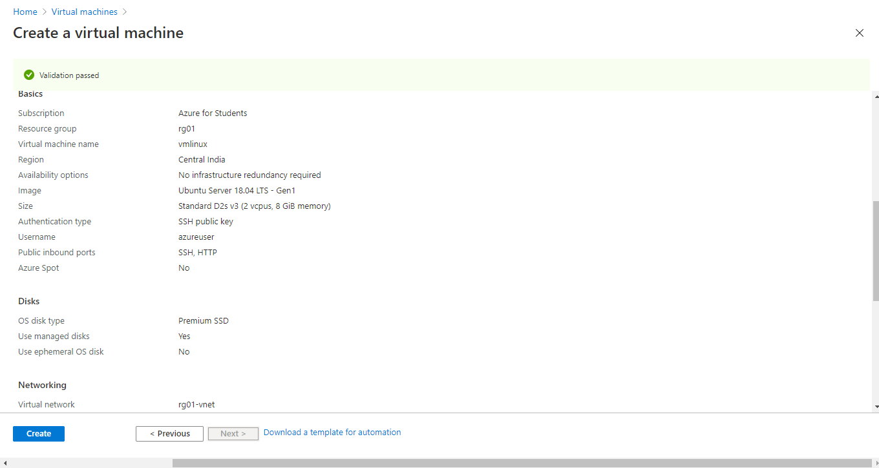

Now open “Putty configuration” to link your linux server.

First configure your Linux VM ip

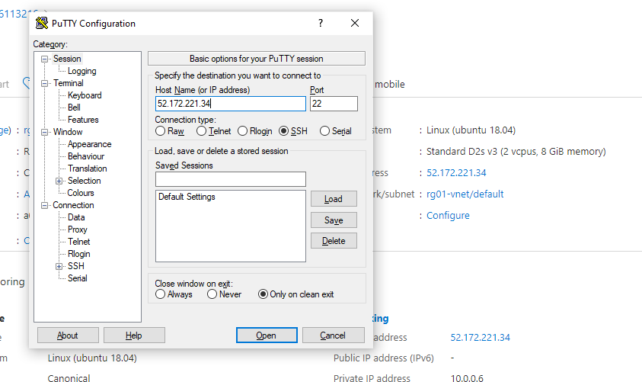

Now, the private key to specify the server belongs to that ip

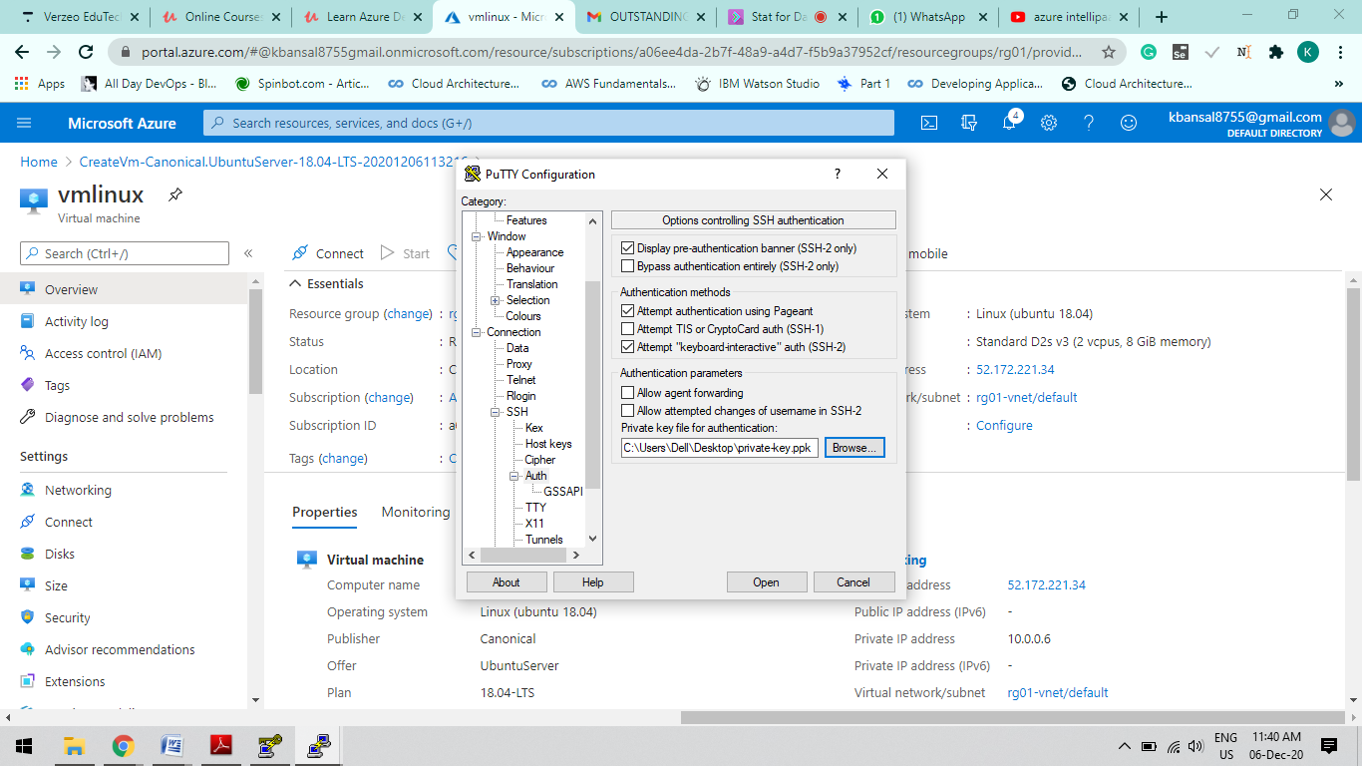

Now after this you will redirect to you VM linux server

Enter the username you give at the time of VM configurations

And you will have the access to the terminal of the linux

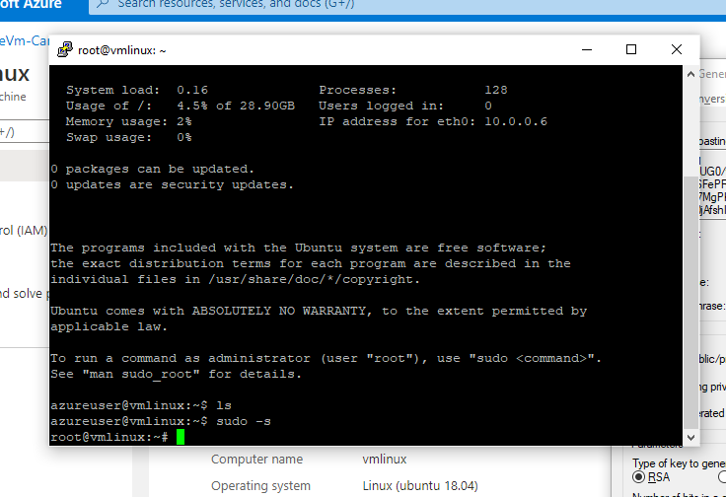

b. Windows VM

Go to Virtual Machine > Resource > add and complete the configuration and set the other data as defaults.

a.

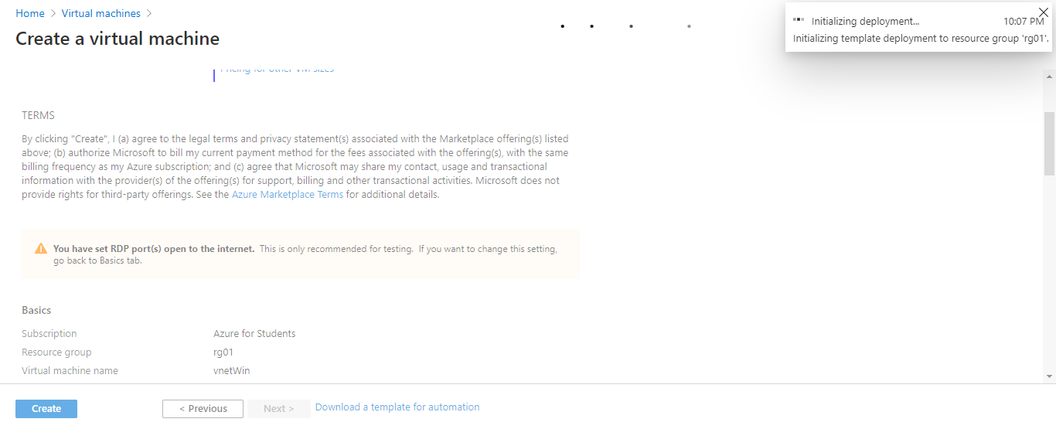

b.

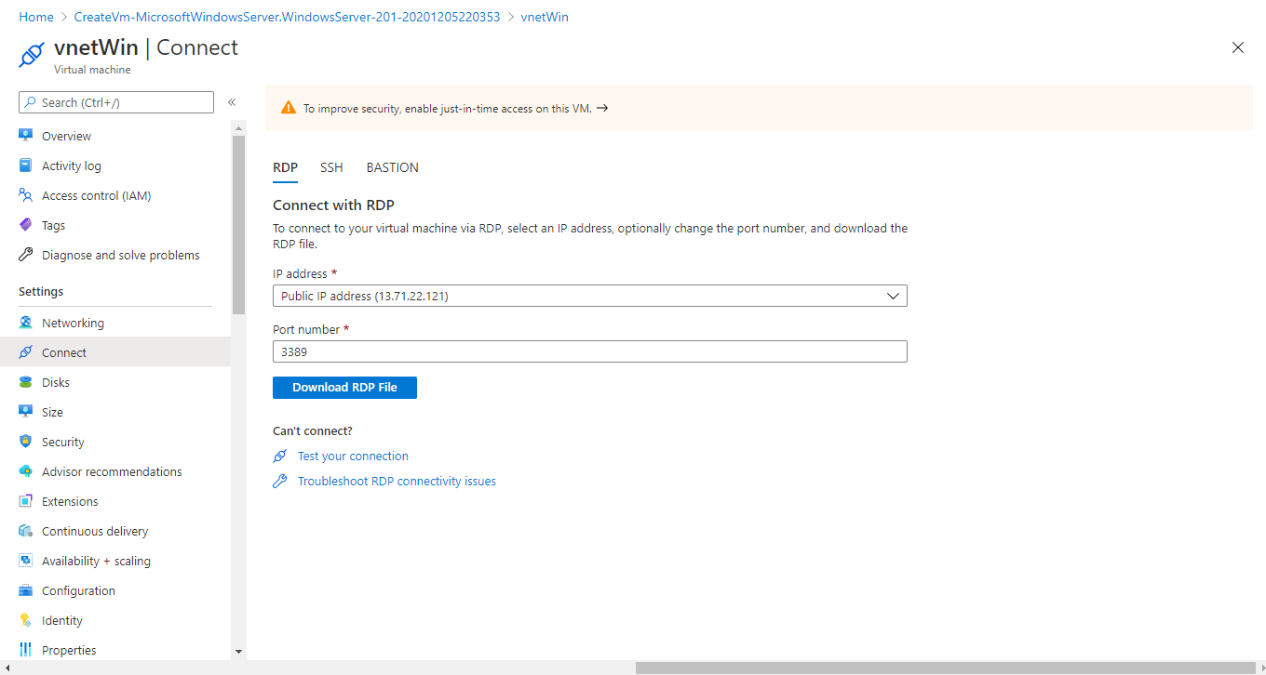

c.

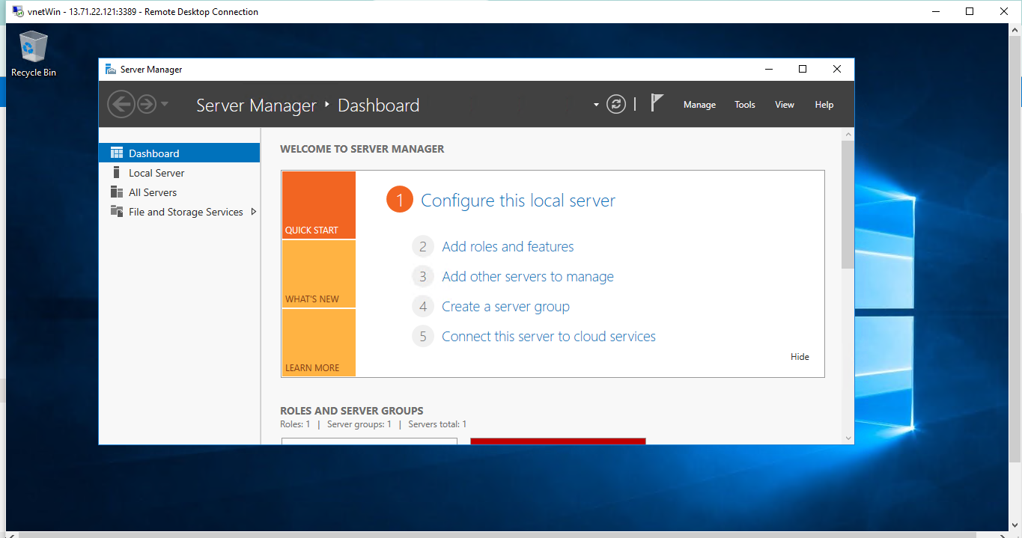

**4. Create blob storage along with the below file share:-**

**Create a File Share (share01) and mount on the window’s VM.**

Create a Storage Account.

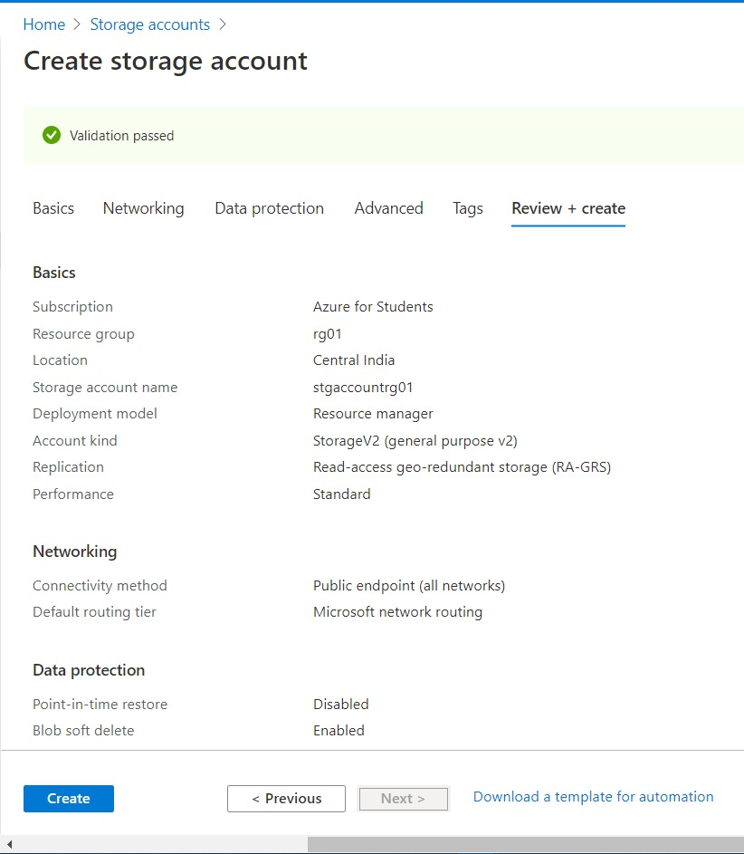

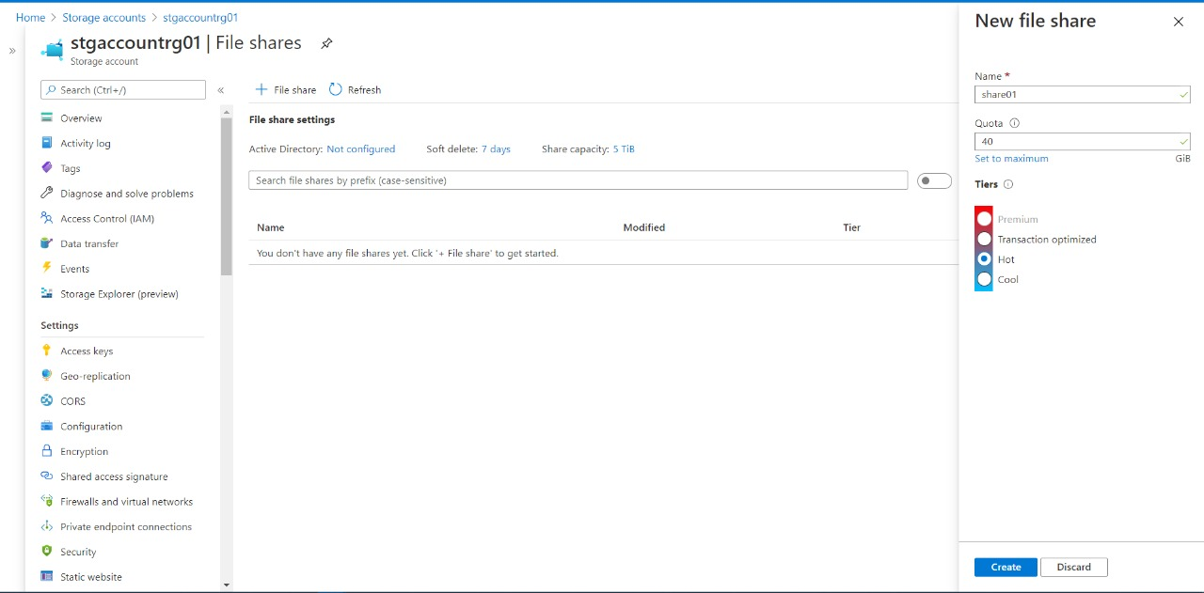

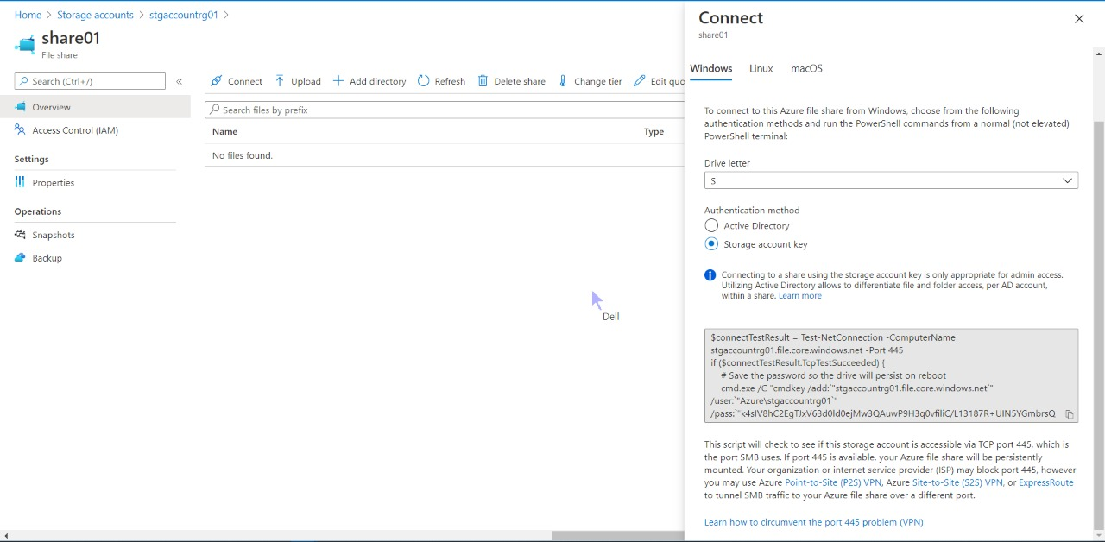

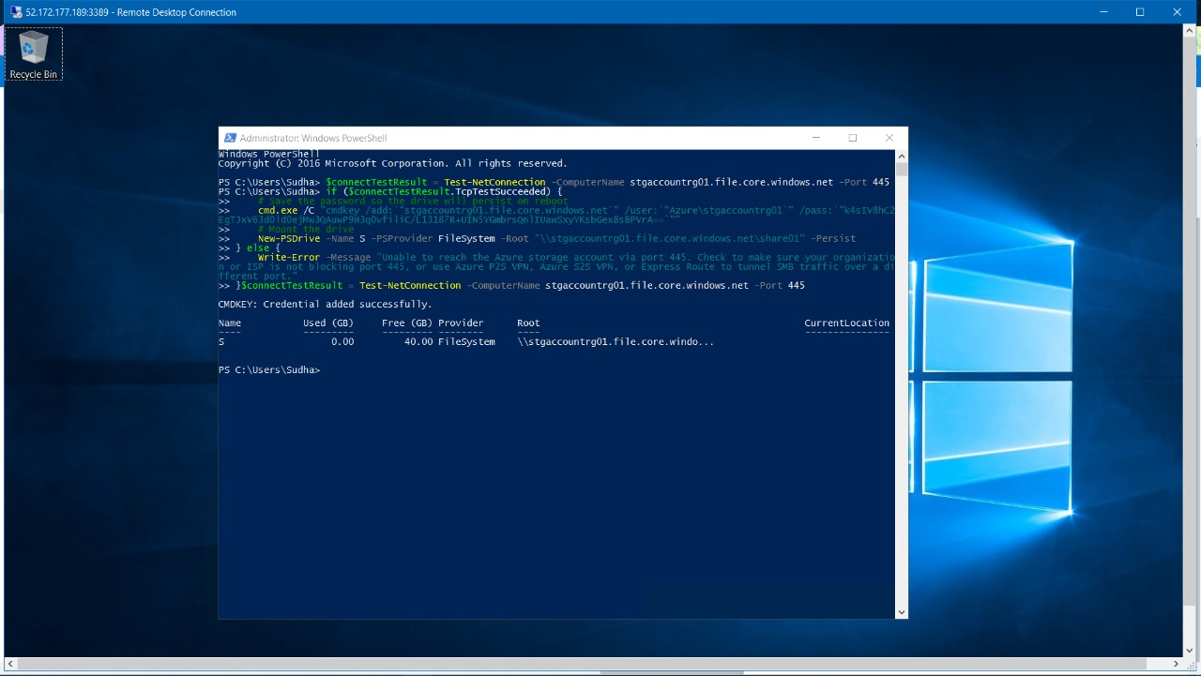

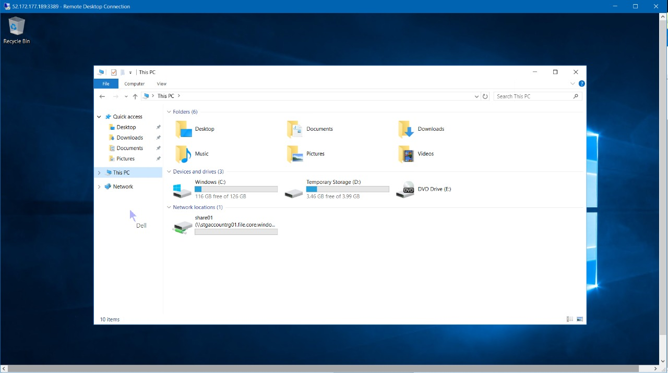

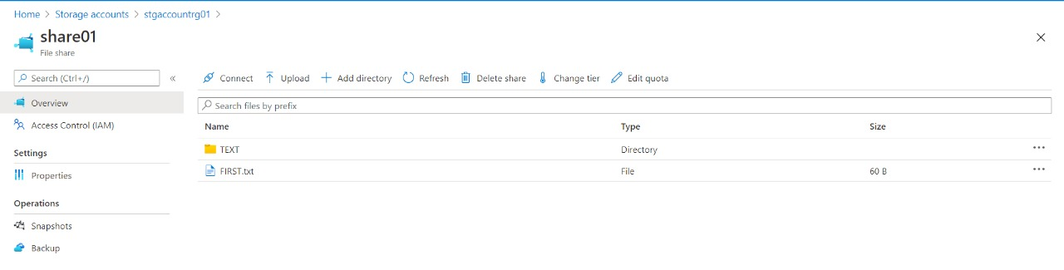

6. Configure an inbound security port rule to allow (RDP & SSH).

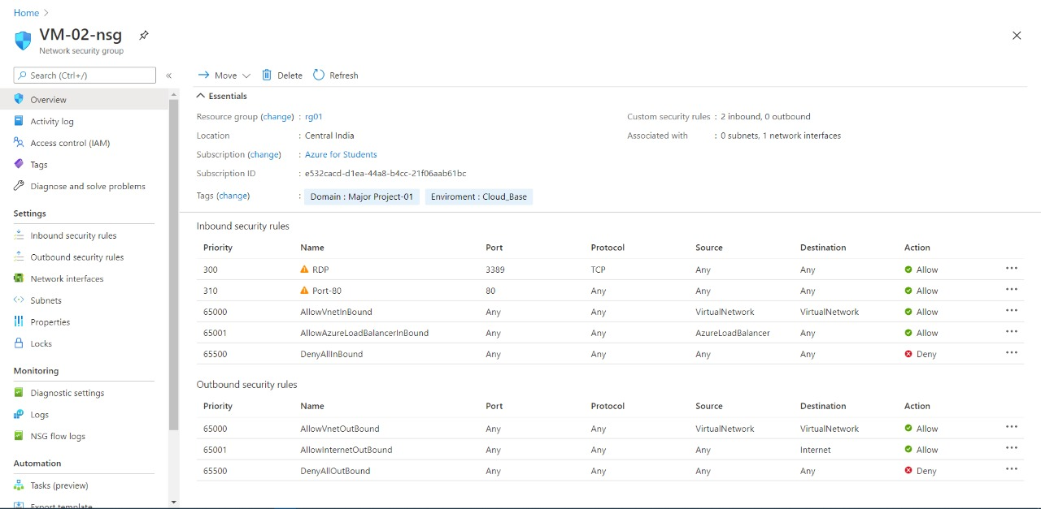

For linux:

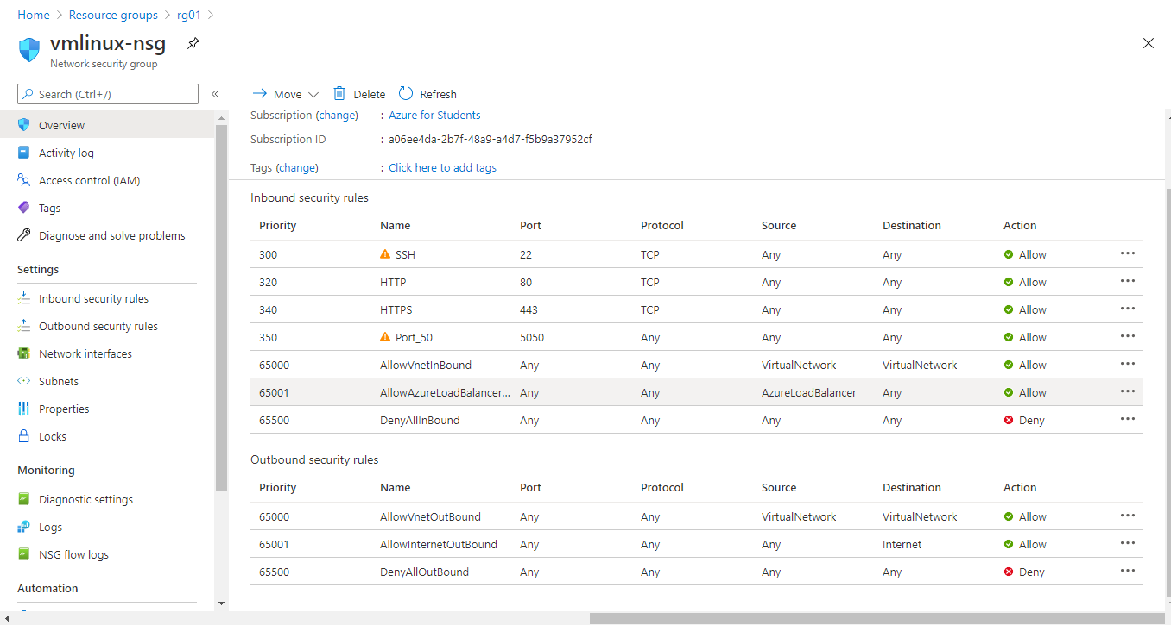

**7. Create Peering between the two Virtual Networks**

It shows an error.

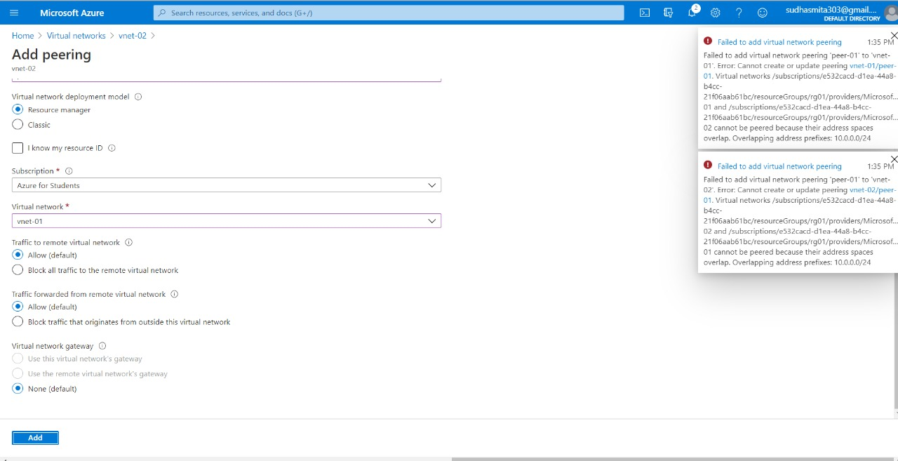

**8. Create a Recovery Services vault (Rsv01) in the Resource Group (rg01).**

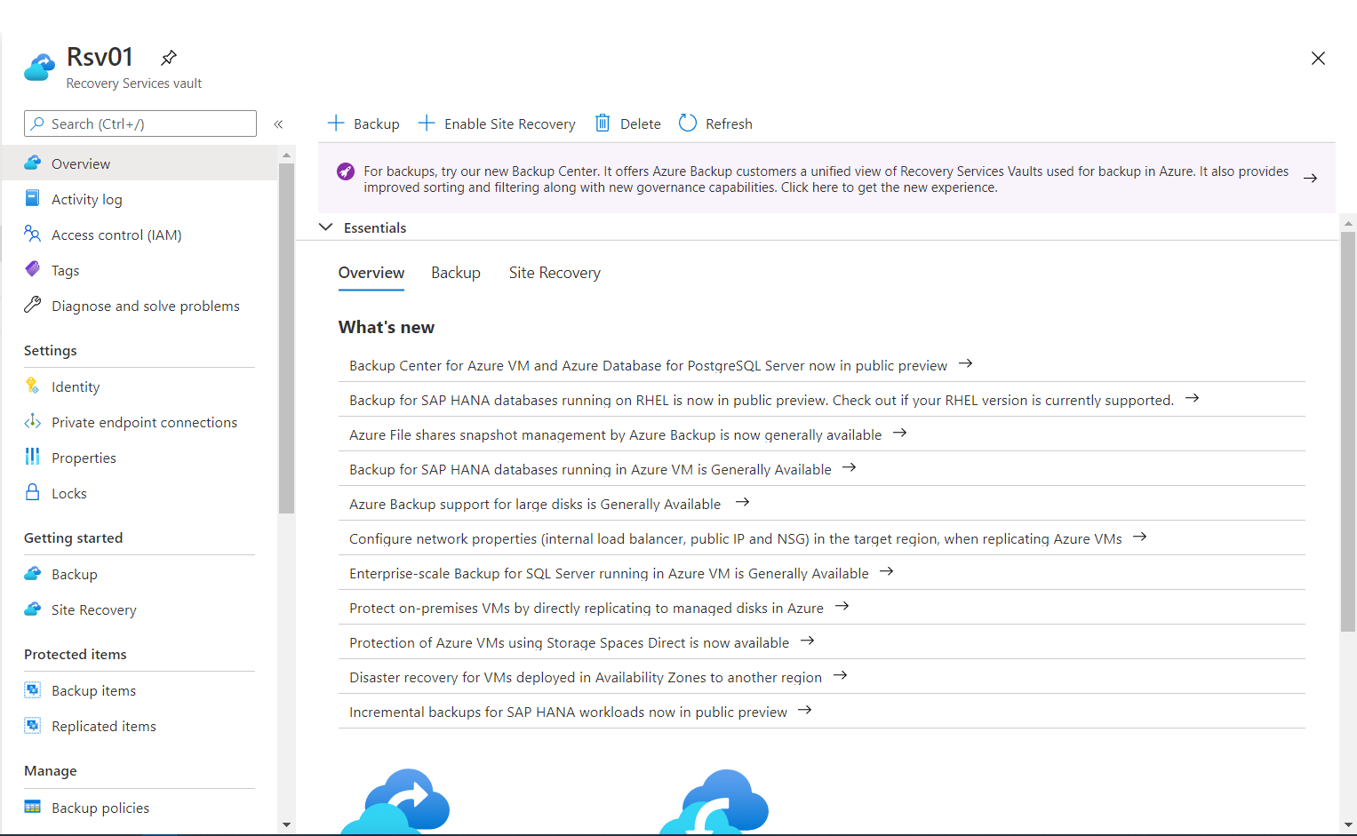

**9. Define Custom policy for Window VM Backup.**

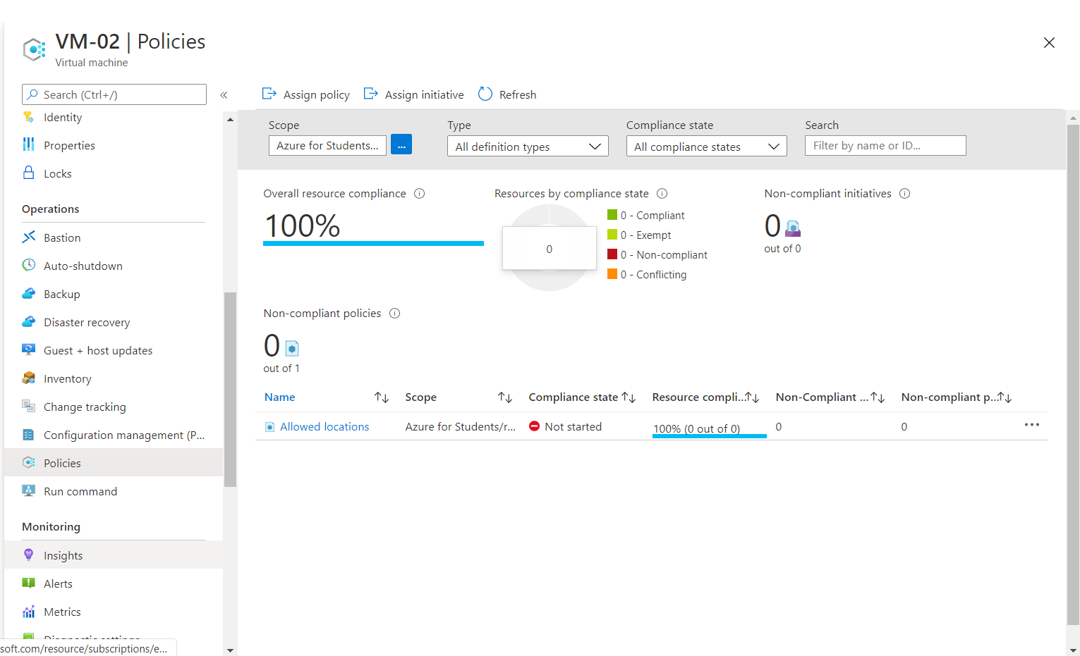

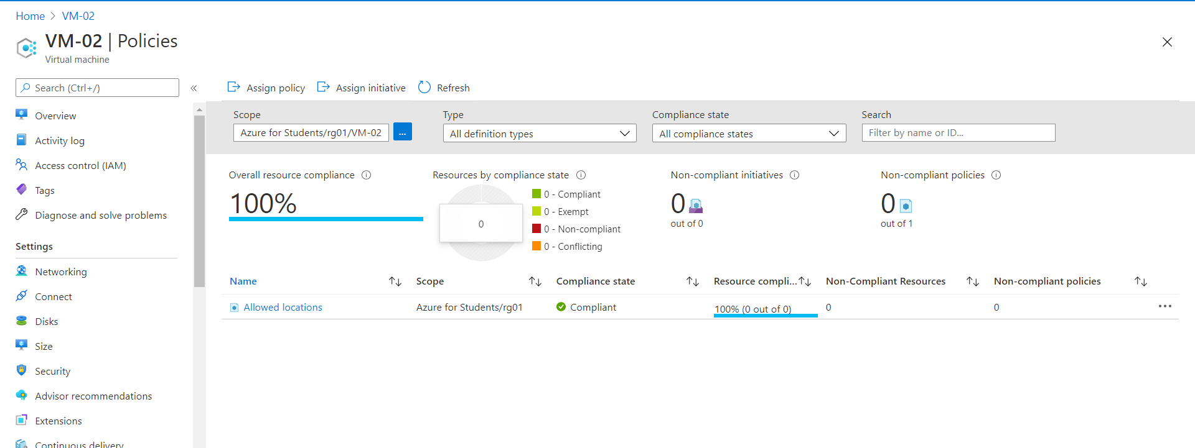

**10. Setup Backup for the Virtual Machine (Windows) and ensure backup is completed successfully.**

* Backup in progress.

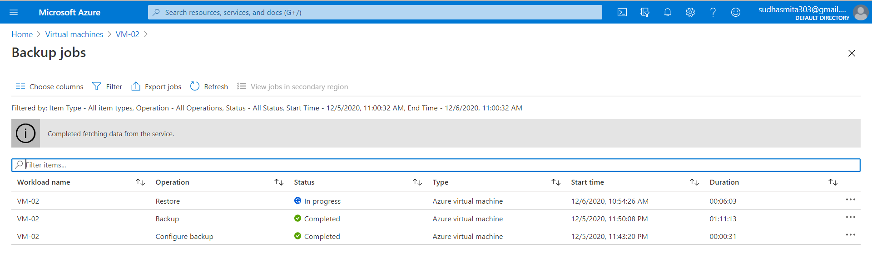

* Backup successful.

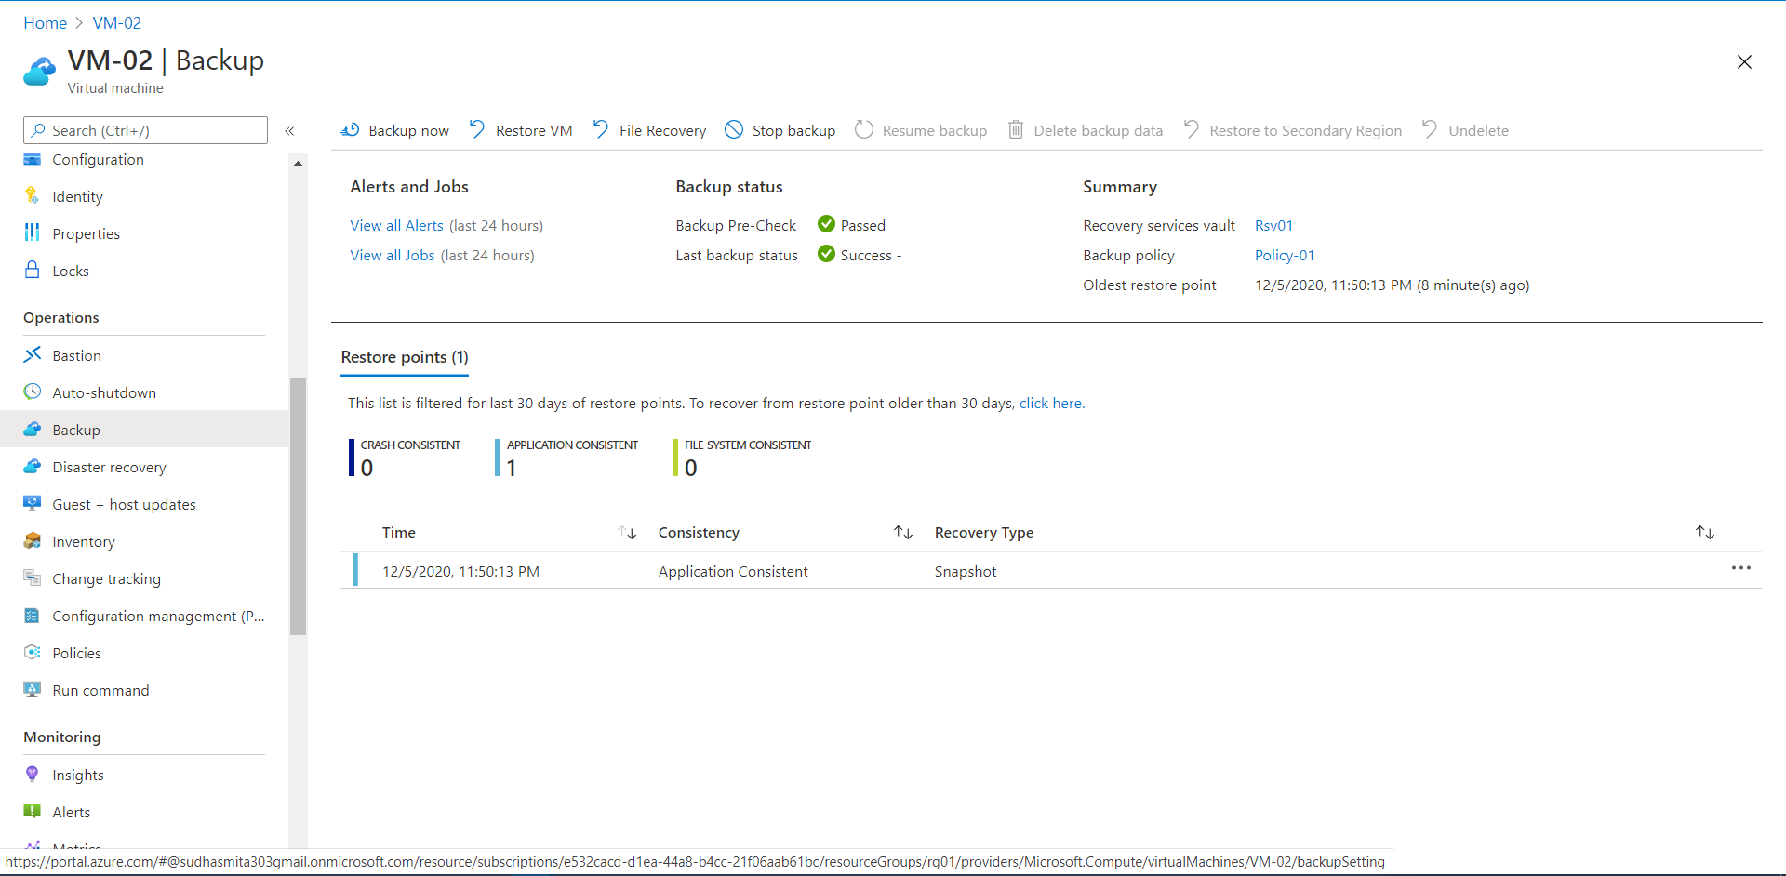

**11. Restore new VM from the backup and delete the older Vm.**

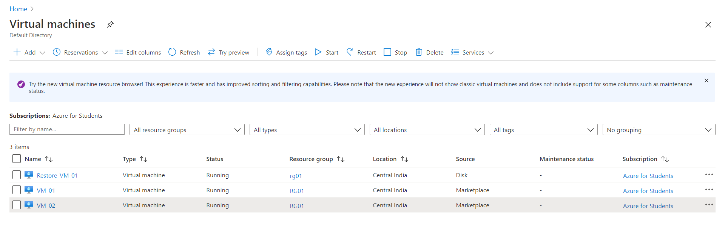

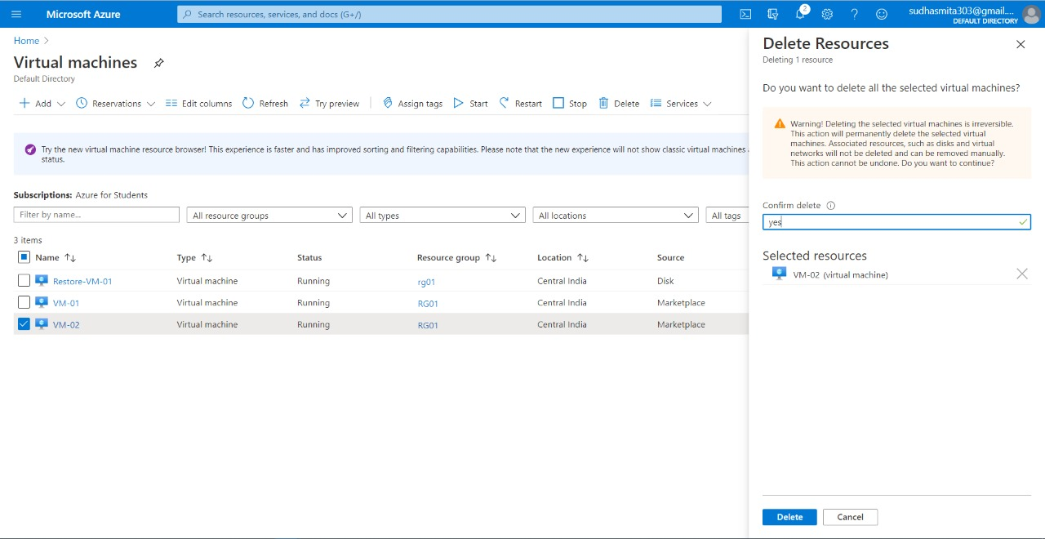



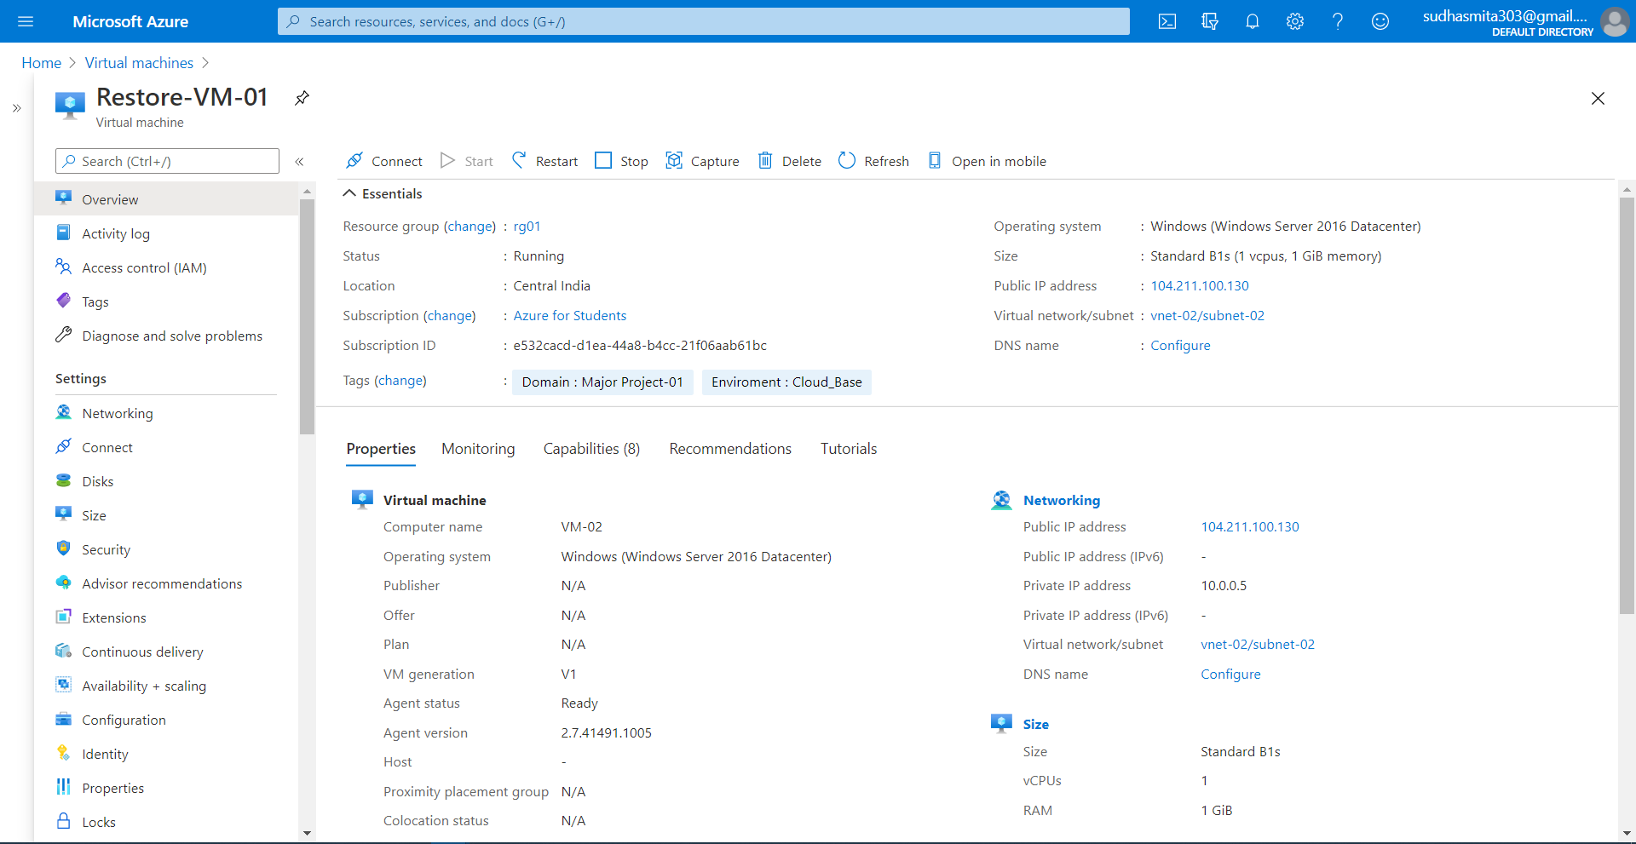

12. - Apply a lock on the (rg01) and test if you are allowed to delete any resource.

Goto Resource Group > rg01 > locks >+ add

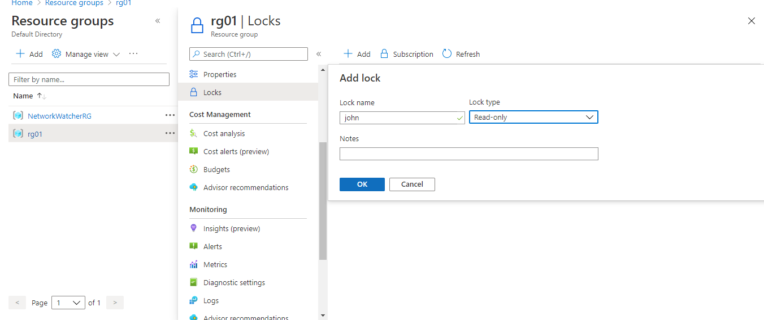

Lets try to delete the resource after the lock.

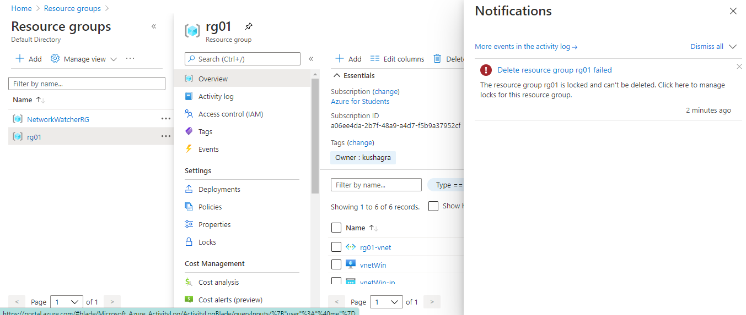

13. - Remove the Lock and delete all the resources after completion of your practical.

Click on delete option.

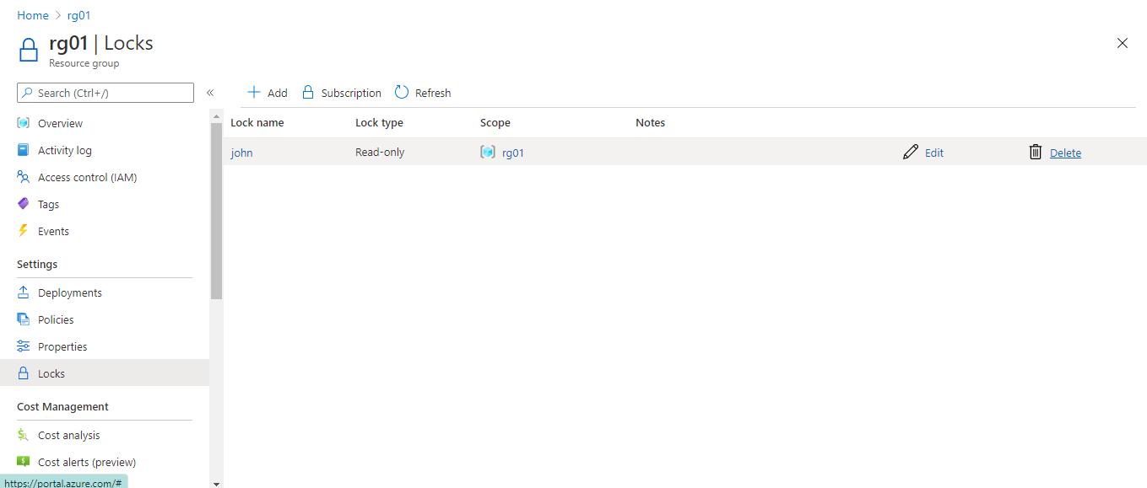

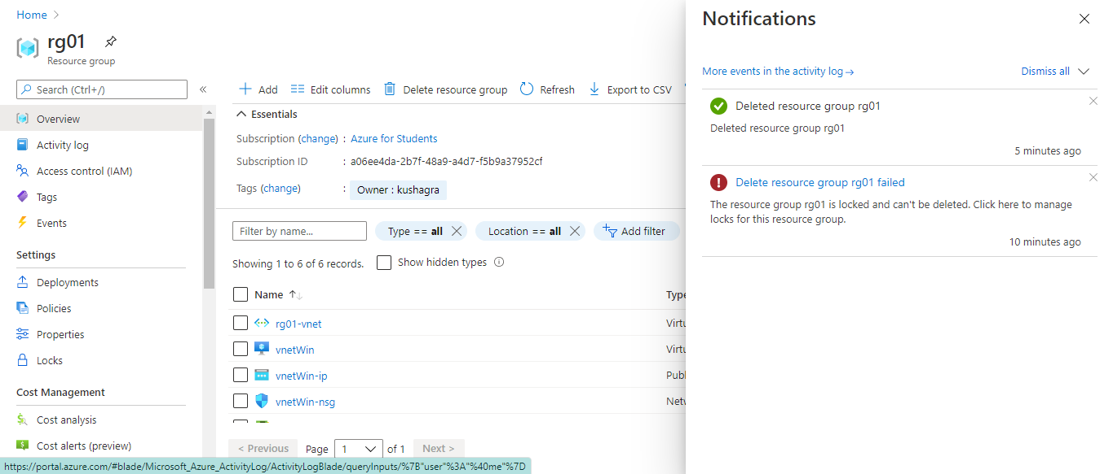

After this if you refreshed the window the resource will be gone.